**NOTES: *Apartheid* in the Republic of South Africa**

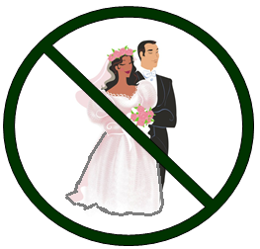Only \_\_% of South Africa’s population is White, but they ran the country from the 1700s to 1994. The worst time was the “Apartheid,” between 1948 and 1994, when South Africa passed \_\_\_\_\_\_ different laws to \_\_\_\_\_\_\_\_\_\_\_ Blacks and Coloureds in South Africa. Some examples . . .

**1949: The Mixed Marriages Act** made it illegal for Whites to \_\_\_\_\_\_\_\_\_ Natives (Blacks) or Coloureds.

**1950: Population Registration Act** required all South African citizens to get officially classified as \_\_\_\_\_\_\_, \_\_\_\_\_\_\_\_\_ African (Black), \_\_\_\_\_\_\_\_\_\_\_\_\_\_ (mixed), or Asian. If there was disagreement about someone’s race, the white \_\_\_\_\_\_\_\_\_\_\_\_\_\_\_\_\_ decided.

**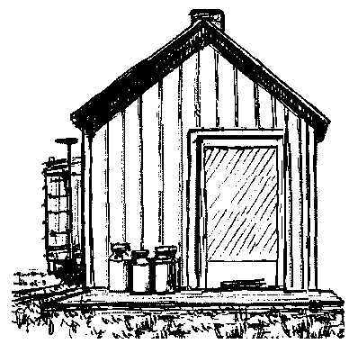**

**1950: Group Areas Act** classified land as “land for Native Blacks,” “land for Coloureds,” and “land for Whites.” If you already lived in a “wrong” area, you had to \_\_\_\_\_\_\_. The \_\_\_\_\_\_\_ city land, industrial areas, and farmland were reserved for \_\_\_\_\_\_\_\_\_\_.

**“**\_\_\_\_\_\_\_\_\_\_\_\_\_\_\_\_\_**”** were set up for Native Blacks. They were usually fairly close to White cities. This gave White factories \_\_\_\_\_\_\_\_\_ \_\_\_\_\_\_\_\_\_\_\_\_ near enough to work for them, but not near enough to be their neighbors.

**1951: Separate Representation of Voters Act** took \_\_\_\_\_\_\_\_\_\_\_\_\_\_ & Asian voters off the national voter rolls.

**1952: Natives Act (Passes Law)** \_\_\_\_\_\_\_\_\_\_\_\_\_\_ all Native Africans (Blacks) to carry an official work \_\_\_\_\_\_\_ with them whenever they left their townships. If you were stopped and didn’t have your pass, you would be \_\_\_\_\_\_\_\_\_\_\_\_\_\_. The pass book included a \_\_\_\_\_\_\_\_\_ ID, birth place, birth date, \_\_\_\_\_\_\_\_\_\_\_\_\_\_\_\_\_\_ record, tax payments, and any interaction with \_\_\_\_\_\_\_\_\_\_\_\_.

MCSL00188_0000[1]Many Native Blacks worked in White areas. At night, a \_\_\_\_\_\_\_\_\_ would sound in the cities and White towns. It meant all non-Whites had to be off the streets in White areas.

Many Native Blacks maids and gardeners lived with their White employers. Their \_\_\_\_\_\_\_\_\_\_\_ and \_\_\_\_\_\_\_\_\_\_\_\_\_\_\_ were not allowed to live with them. Children were raised by friends or relatives in the Black townships. Families were \_\_\_\_\_\_\_\_\_\_\_\_\_\_\_\_ under this system.

**1953: Bantu Education Act** said public schools could not be racially \_\_\_\_\_\_\_\_\_. Schools for Native Blacks could no longer teach much \_\_\_\_\_\_\_ or \_\_\_\_\_\_\_\_\_\_\_\_. Government leaders explained: “We \_\_\_\_\_\_\_ want Native African kids to think they can grow up to do the same things Whitekids can do. So we’ll only educate them to be maids, cooks, mine workers, gardeners – to work with their \_\_\_\_\_\_\_\_\_.” \_\_\_\_\_\_\_\_\_\_\_ Black public schools received about \_\_\_\_\_\_ of the money – perstudent – that \_\_\_\_\_\_\_\_ public schools received.

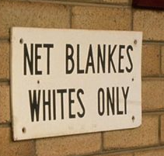**1953: Reservation of Separate Amenities Act** required \_\_\_\_\_\_\_\_\_\_\_\_\_\_\_ facilities for Whites and “others” in public services, public \_\_\_\_\_\_\_\_\_\_\_\_\_\_\_\_, and public \_\_\_\_\_\_\_\_\_\_\_\_\_\_\_\_\_\_\_\_\_\_\_\_\_\_\_. The goal was to stop casual \_\_\_\_\_\_\_\_\_\_\_\_\_ between White and other races. This included almost everything: bathrooms, \_\_\_\_\_\_\_\_\_\_\_\_\_, \_\_\_\_\_\_\_\_\_\_\_\_\_\_\_ events, busses & \_\_\_\_\_\_ stops.

**1970: Bantu Homeland Citizens Act** declared all Blacks to be citizens of their “homeland” (\_\_\_\_\_\_\_\_\_\_\_ \_\_\_\_ citizens of South Africa).

**Apartheid is GONE from South Africa today. How do you suppose they finally got rid of apartheid?**

**NOTES: Ending *Apartheid***

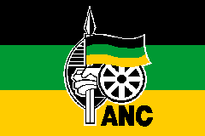A group called the **A**\_\_\_\_\_\_\_\_\_\_\_\_\_ **N**\_\_\_\_\_\_\_\_\_\_\_\_\_\_\_ **C\_\_\_\_\_\_\_\_\_\_\_\_\_\_\_ (ANC)** formed to work for Native rights. A young man named Nelson \_\_\_\_\_\_\_\_\_\_\_\_\_ joined. He was a tribal chief’s son. But he also went to college and to law school. He helped fight apartheid as a \_\_\_\_\_\_\_\_\_\_\_\_ .

But the South African government didn’t let up. In 1960, they banned public \_\_\_\_\_\_\_\_\_\_\_\_\_\_\_ and arrested almost \_\_\_\_\_\_\_\_\_ people. The ANC and other protest groups were \_\_\_\_\_\_\_\_\_\_\_\_\_\_. Nelson Mandela and other ANC leaders were eventually arrested and sentenced to many \_\_\_\_\_\_\_\_ of hard labor.

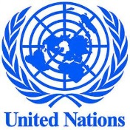Over the years, the \_\_\_\_\_\_\_\_\_\_\_\_\_\_ in South Africa grew. South African police responded \_\_\_\_\_\_\_\_\_\_\_\_\_\_\_, doing exactly what they had been \_\_\_\_\_\_\_\_\_\_\_\_ to do at their Police Academy.

**International pressure** grew quickly after 1960.

* **1962 – United Nations** asked countries not to \_\_\_\_\_\_\_\_\_ with South Africa.
* [](http://www.sahistory.org.za/dated-event/ioc-extends-south-africa039s-ban-olympic-games)**1964:** South Africa was banned from the **Tokyo Olympics** (because they won’t let non-Whites on their teams).
* **1970: International Olympic Committee** totally banned South Africa from \_\_\_\_\_ Olympic competition.
* 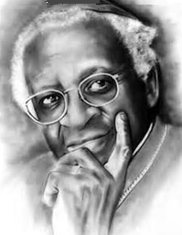The **Anglican** \_\_\_\_\_\_\_\_\_\_ **(British Episcopal Church)** sent a \_\_\_\_\_\_\_\_\_ pastor to be the Archbishop in South Africa.
* **1977: U.S. universities** started taking $$ back out of South African businesses
* **1985: International banks** demanded loans be \_\_\_\_\_\_\_ \_\_\_\_\_\_\_ – immediately.
* **1986: U.S. \_\_\_\_\_\_\_\_\_\_\_\_\_\_\_\_ passed the Anti-Apartheid Act,** making it illegal for American companies to do business with South Africa.

**The idea was this:** If the world pulled their \_\_\_\_\_\_\_\_\_\_ out of South Africa, the South African government would HAVE TO change their policies – or go\_\_\_\_\_\_\_\_\_!

**The impact?** In 1986, \_\_\_\_\_\_\_\_\_\_\_\_\_\_\_\_ were finally ended. In 1989, a \_\_\_\_\_ President was elected. He was White, but he knew things had to \_\_\_\_\_\_\_\_\_\_\_. President DeKlerk convinced his government to \_\_\_\_\_\_\_\_\_\_\_\_\_ Mandela from prison – 28 years after he went to prison.

**In 1994, Nelson Mandela** ran for \_\_\_\_\_\_\_\_\_\_\_\_\_\_\_\_\_of South Africa & won. It was the first election where all South Africans could vote.

Even after all he had \_\_\_\_\_\_\_\_\_\_\_\_\_\_\_, he pushed the policy of a “\_\_\_\_\_-\_\_\_\_\_\_\_\_\_\_\_\_” South Africa – a country for – Blacks, Coloured, Asians, and Whites.

**After 300 years of Whites-only policies,** South Africa will need time to \_\_\_\_\_\_\_\_\_\_\_\_\_ and catch up to the rest of the world.

[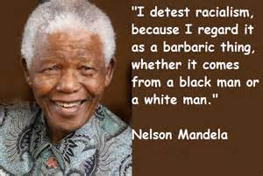](http://images.search.yahoo.com/images/view;_ylt=A0PDoS1n0QlSpCIAKy6JzbkF;_ylu=X3oDMTFya2tpaWptBHNlYwNzcgRzbGsDaW1nBG9pZAM0MGJkODE2NTUyNjhkMDYyNmFiMTZiNDU4NmYwYWM1MQRncG9zAzUy?back=http://images.search.yahoo.com/search/images?p=nelson+mandela+quote&n=30&ei=utf-8&fr=yfp-t-129&tab=organic&ri=52&w=598&h=402&imgurl=thisbugslifedotcom.files.wordpress.com/2013/06/nelson-mandela-quotes-6.jpg&rurl=http://thisbugslife.com/2013/06/12/nelson-mandela-quotes/&size=80.2KB&name=%3cb%3eNelson+Mandela+%3c/b%3eQuotes+|+Janet+Carr+@&p=nelson+mandela+quote&oid=40bd81655268d0626ab16b4586f0ac51&fr2=&fr=yfp-t-129&tt=%3cb%3eNelson+Mandela+%3c/b%3eQuotes+|+Janet+Carr+@&b=31&ni=72&no=52&ts=&tab=organic&sigr=11pj23heq&sigb=13g7dn7kc&sigi=12adfg245&.crumb=DgW1UpHo3Kx&fr=yfp-t-129)