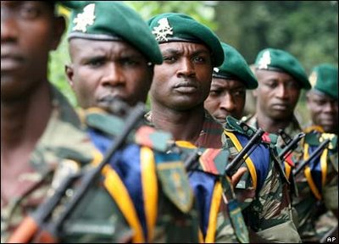
NIGERIA’S STRUGGLE FOR DEMOCRACY

Nigeria, Africa’s most populous nation, is composed of more than 250 ethnic groups, speaking many languages. Three ethnic groups, however, dominate this West African country; the Hausa-Fulani is the largest ethnic group, making up 30 percent of Nigeria’s population. The Yoruba and Igbo with homelands in the south make up about 20 percent of Nigeria’s people.

People first inhabited the area surrounding the Niger River thousands of years ago. Over the centuries, kingdoms and empires rose and fell, usually as the result of warfare.
In the 1300s, Muslim preachers who followed caravan routes from North Africa began to convert the Hausa-Fulani. By the mid-1800s, European and American Christian missionaries were making many converts with the Yoruba and Igbo people. By the beginning of the 20th century, the European powers divided Africa among themselves and drew boundaries that often combined ethnic groups hostile to one another.

A few years before independence, vast oil deposits were found in the Niger River Delta. This seemed to assure a bright future for Nigeria. But many things went awfully wrong. The three major ethnic political parties competed to win control of the national wealth. The Hausa-Fulani, Yoruba, and Igbo political leaders wanted the oil money to enrich themselves and their regions. Thus, greed and corruption soon became common in Nigerian politics. With oil money flowing into the pockets of government officials and their friends, the ruling party ignored the needs of the Nigerian people.

Fearing the Muslim Hausa-Fulani would never give up control of the government, Igbo military officers staged a military coup (government
take-over). Members of the government, including the Prime Minister, were murdered. Ethnic hatred kept boiling over. The Nigerian Civil War lasted more than two years and killed about 1 million people. More died from starvation than bullets.

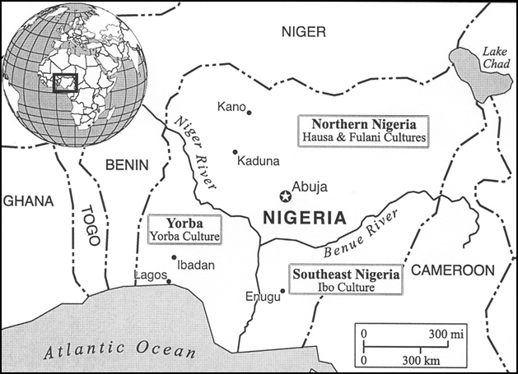
High world oil prices continued to inject huge amounts of cash into Nigeria’s treasury. In fact, Nigeria became one of the richest countries in the world. But the military officers in charge of the government turned out to be just as greedy as the elected politicians had been. The oil revenue could have modernized Nigeria’s agriculture, developed its manufacturing, built roads, financed schools, and accomplished many other things for the Nigerian people.

Faced with economic decline and the growing unpopularity of military rule, a new leader supervised the writing of a second constitution. It enabled the people to elect a president directly. The constitution also required all political parties to include different ethnic groups from all parts of the country. At first, the new government took positive steps to improve Nigeria by expanding the public school system, universities, and hospitals.

In the midst of this economic disaster, religious conflict between Muslims and Christians continued to erupt. Since Muslims make up the country’s largest religious group, some have long demanded that Nigeria become an officially Islamic nation. They have called for Islamic religious law, called Sharia, to apply throughout the land. The Christian minority has opposed such a move, fearing second-class citizenship.

In 1989, the military government oversaw the writing of a new constitution. By this time, Nigeria was one of the 20 poorest nations in the world. Moreover, 50 years of careless oil spills by foreign companies severely polluted Niger Delta farmlands and fishing waters. Nigerians began to organize peaceful protests against Nigeria’s government and the oil companies, demanding a fair share of oil revenue and help from oil companies to get clean water, electricity, and health care. The current government faces numerous longstanding problems in Nigeria. Great distrust still prevails between the Hausa- Fulani in the north and the Yoruba and Igbo in the south.
Bill of Rights in Action, 2010 & Geography in the News

