CHILD SOLDIERS
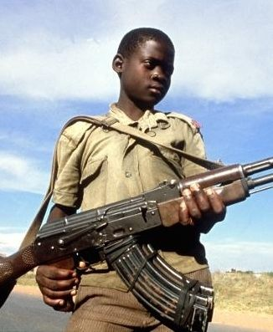
The use of child soldiers is one of the world's most horrendous types of child abuse. It is a practice that continues in many war-torn countries. Even though child soldiering has been universally condemned as abhorrent and unacceptable, estimates show that hundreds of thousands of children have fought and died in armed conflict over the last decades. It is virtually impossible to document the exact number of child soldiers because the numbers fluctuate constantly. Thousands of children have been mobilized in countries like Angola, Afghanistan and Sierra Leone- thousands more have been recruited into new conflicts.
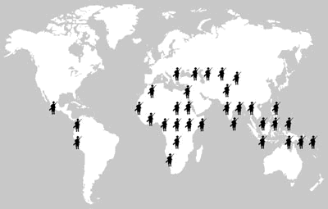
Human Rights Watch, an international watchdog group, estimates that between 200,000 and 300,000 children under the age of 18 serve as soldiers for government forces and rebel groups in current armed conflicts. Myanmar is the most persistent user of child soldiers in the world. Government armed forces forcibly recruit and use children between the ages of 12 and 18, though some are as young as 11. Nepal's communist rebellion, the conflict in and around India's Kashmir and southern Thailand involve child soldiers. In Sri Lanka's Tamil rebellion,thousands of child soldiers are used. Child soldiers are also reportedly used in the Southwest Asian countries of Afghanistan and the occupied Palestinian territories. In Latin America, as many as 14,000 children are believed to be involved with the guerrilla/drug war in Colombia.
Children are recruited in several ways, including personal and family threats and coercion or promises of food, housing, pay and other benefits. In war-torn places, daily threats, ambushes and assassinations lead youths to be attracted to whoever can provide personal protection. The life of a child soldier is dangerous, as they are forced to perform the most hazardous missions, such as placing landmines, handling explosives and using assorted weaponry. If they make a mistake or try to leave the ranks, punishment can be severe, even resulting in death.
Collectively, the magnitude of conflicts using child soldiers and the toll their recruitment takes on a generation of each country's children is mind boggling. Children who actively participate in and survive war unfortunately may never be able to function emotionally as normal adults. But, cultural conflicts and economic inequality in impoverished countries play a major role in the problem of child soldiering. As long as children in these countries are poor and hungry and have little hope for their own futures, they will likely choose to fight rather than starve.
Geography in the News

